APPENDIX C (END-USER & ADMINISTRATOR MANUALS)

User guide for administrator

This manual is for administrator

User guide for end user

This manual is helpful for normal user who’s using our application for the first time.

## Home Page

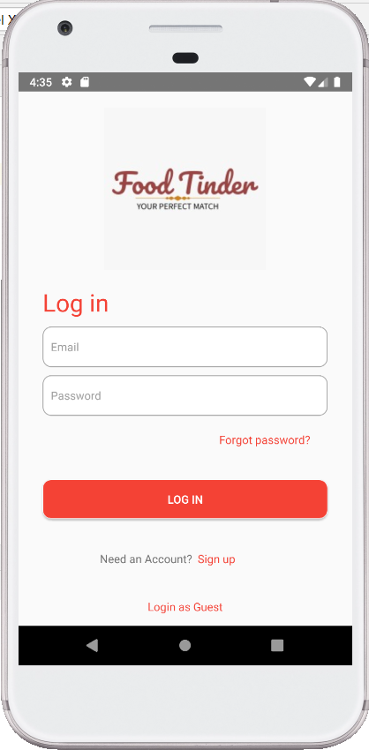

When you run the application, this homepage will show up. In this screen, you can either 1) log in, 2) sign up, or 3) login as guest.

## Sign up

1. 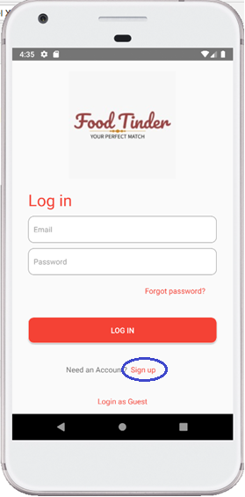To create a new account, click “Sign up” button in homepage.

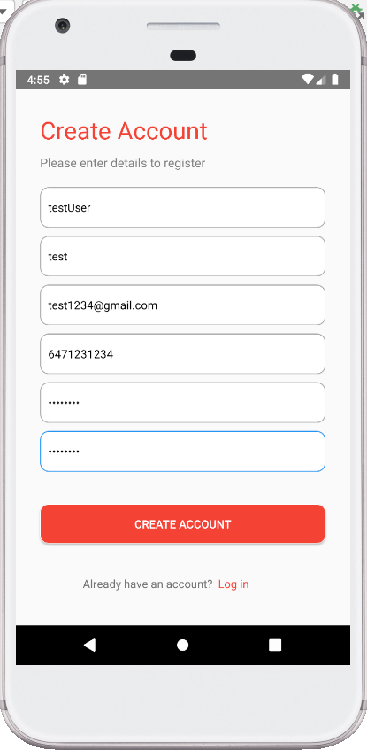

1. After filling the form, click “CREATE ACCOUNT”.

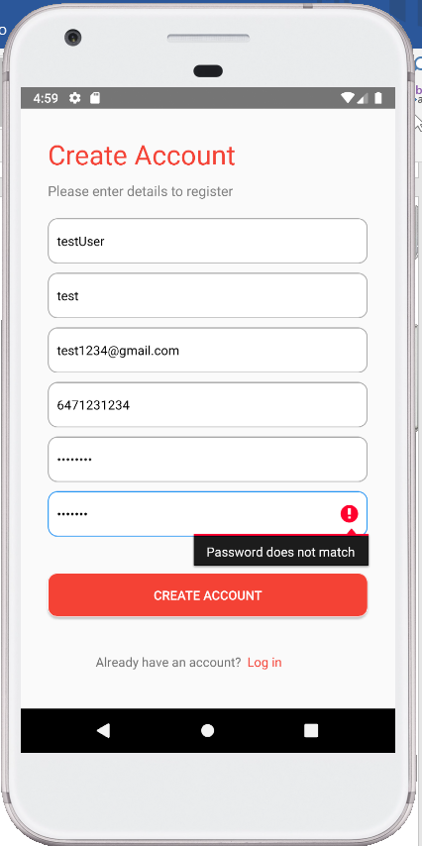

* 1. If there is an invalid input, error message shows up.

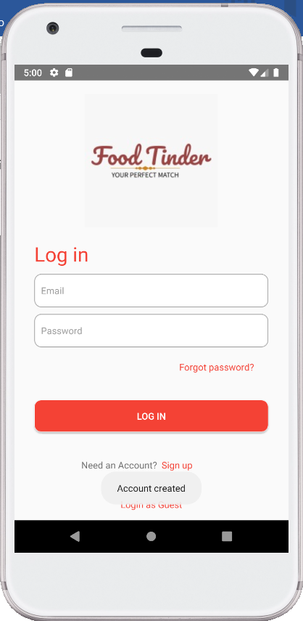3.2 If registration is successful, you will be navigated to homepage and able to login with the new account.

## Login

## 

In order to login, enter account information and click “LOG IN”

## View account information

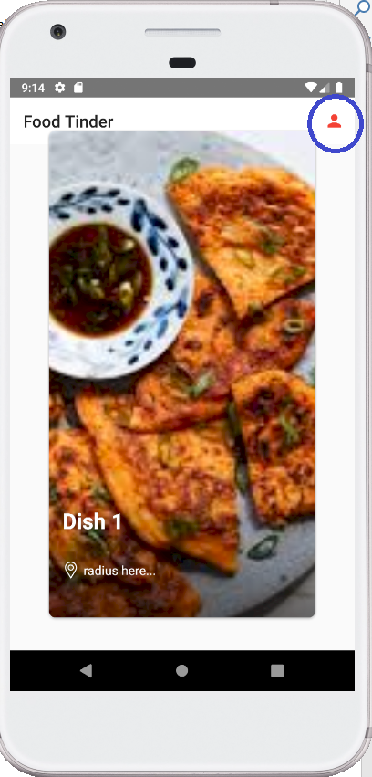

1. To see account information, click an icon on the top right in Finding Match screen.

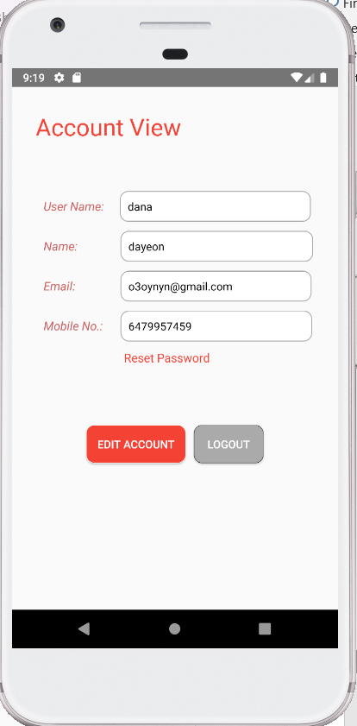

1. Your information will be shown.

## Edit user information

There are two information you can edit here: 1) basic information 2) reset password.

1. To edit basic information, click “EDIT ACCOUNT”
2. 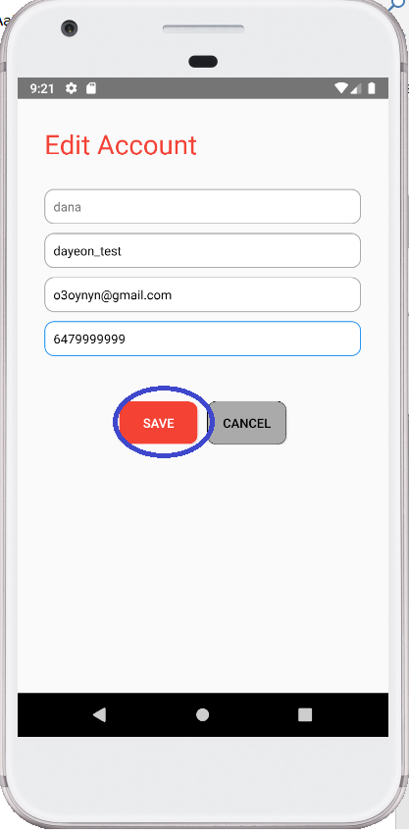Enter new information, and click “SAVE”. The new information will be saved in your account.

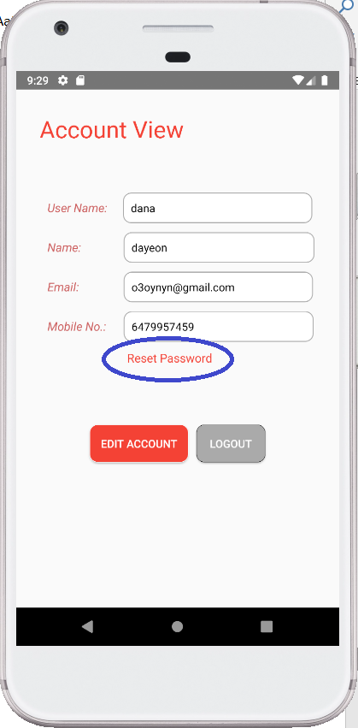

Now, we will talk about how to change password.

1. Click “Reset Password”

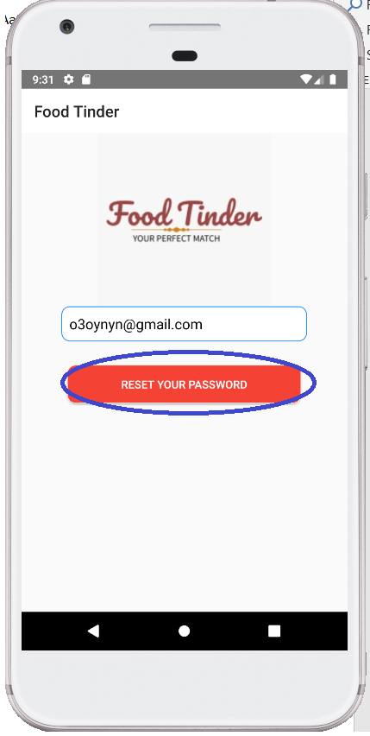

1. Enter your email address (email address should be registered in the application), and click “RESET YOUR PASSWORD”. Check inbox in your email.

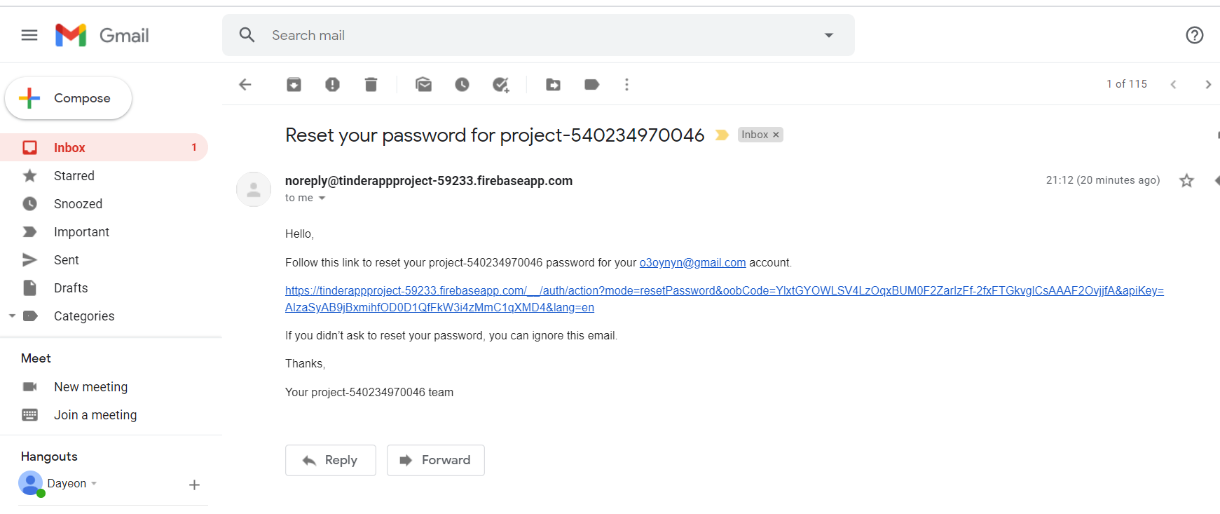

1. You will find this email. Click the link.

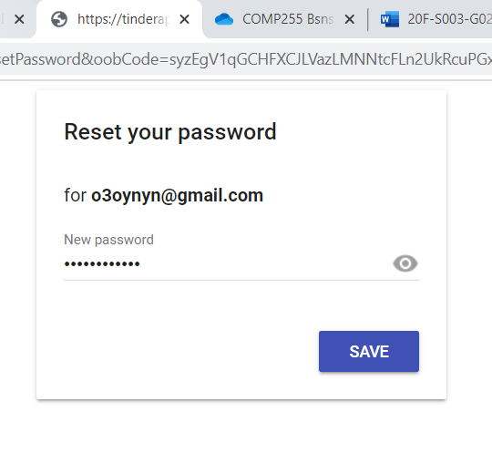

1. Click “SAVE”. New password has been saved.

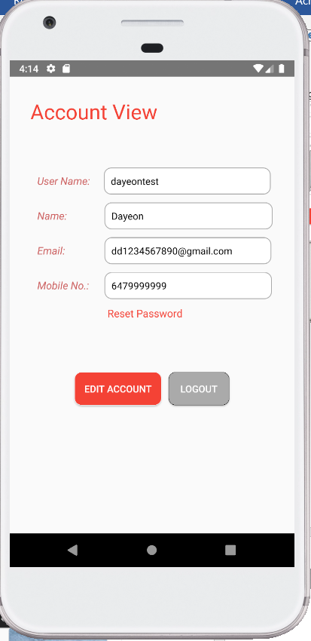

## Edit account information

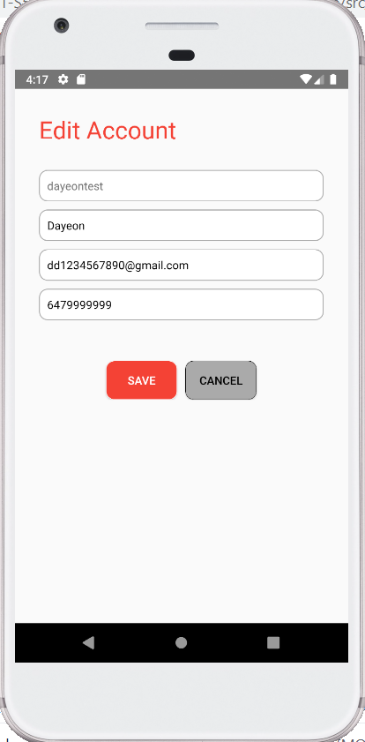

Find a match

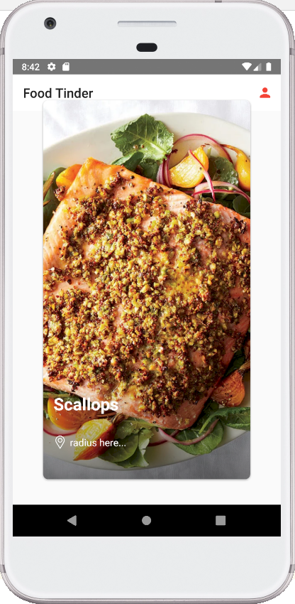

Once you login (either with your account or as a guest), you first are navigated to ‘Find Match’ page. One food picture will be shown on the screen at a time. The only information given about the food is food restrictions and how far the place(restaurant) it is from location that user set. If you want to see details about the food or information about the restaurant serving the food, swipe right on screen. The restaurant information and their menu will be shown. If you want to pass on the displayed food and move to the next one, swipe left.

Get the matched restaurant’s information

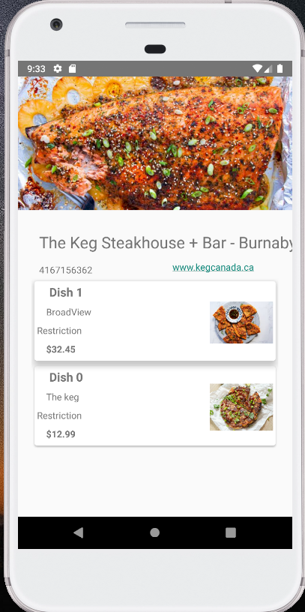

Once you swipe right on a food picture in finding match, you automatically see restaurant information page. The food you swiped on is located in the top of the menu, and will be noticeable to you as the dish card will be shaking for a second. If you click on website URL, the website will open in your internet browser. If you click on phone number, your phone will dial to the restaurant.

## See existing menu -> navigation part needed

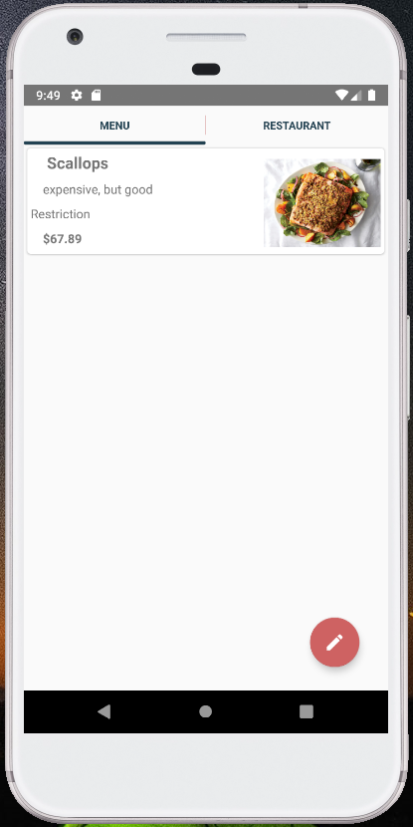

When you click ( ), you will be navigated to this page. You can switch to restaurant information by clicking ‘RESTAURANT’ on the right top. Menu items you currently have will be shown. Each menu contains its name, description, restriction, price, and picture.

## See restaurant information -> navigation part needed

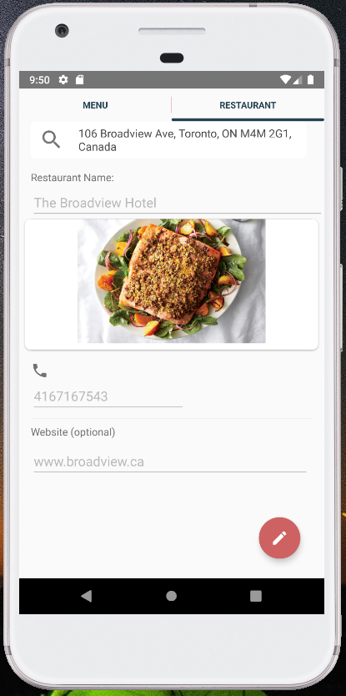

When you click ( ), you will be navigated to this page. You can switch to menu information by clicking ‘MENU’ on the left top. Your restaurant information will be shown. Restaurant information contains its address, name, picture, phone number, and website.

## Add a new menu

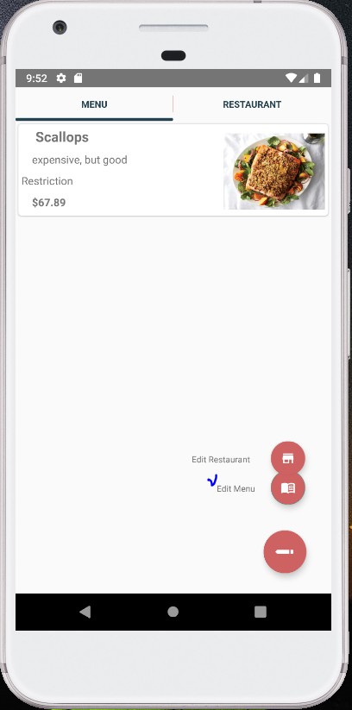

1. In order to add a new menu, go to ‘See existing menu’ page and click pencil button on the right bottom. ‘Edit Restaurant’ and ‘Edit Menu’ will show up. Click ‘Edit Menu’.

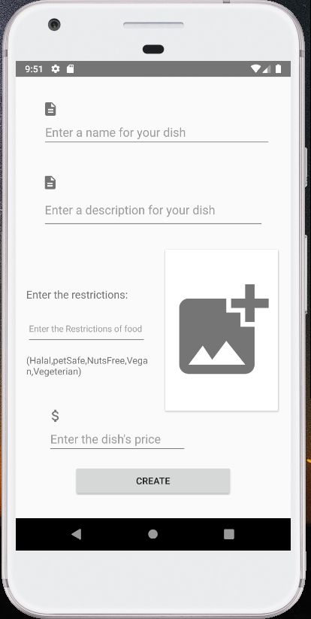

1. The application will navigate you to this page.
2. 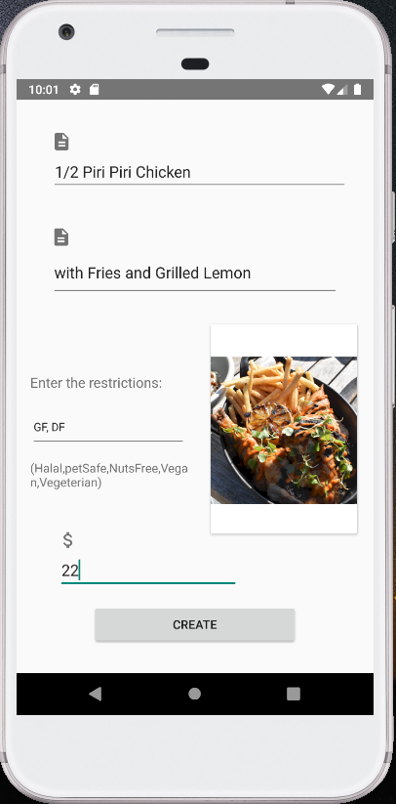Enter menu information, and click ‘CREATE’
3. 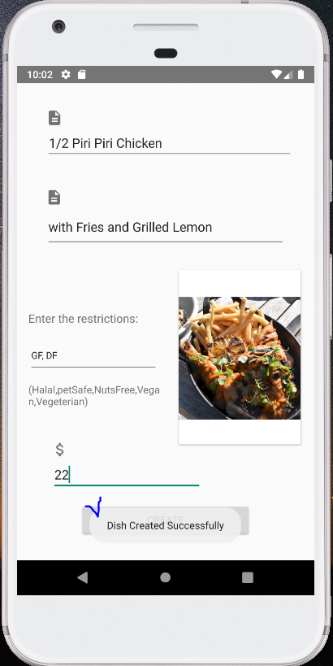If the menu is successfully added, ‘Dish Created Successfully’ message will pop up.

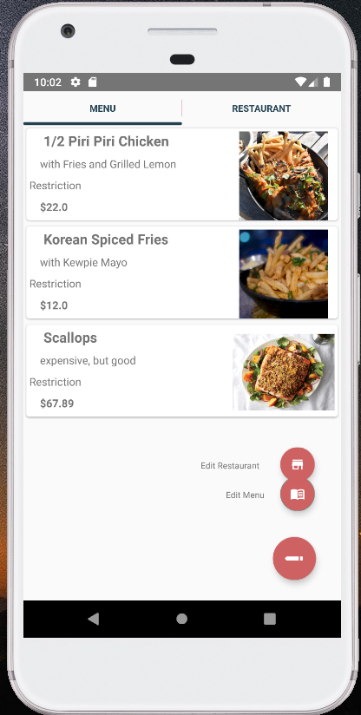

1. Go back to menu list, and check if the menu was added.